**Lab 2: Analog to Digital Converter**

**Keegan** **Smith**

**Bench** 02

**Electronics** II Lab

**EECE.3120 803**

**Date submitte**d 09/20/2022

**Due date** 09/21/2022

1. **SUMMARY**

In this lab we perform series of experiments using an analog to digital converter (ADC) to gain experience in this universal IC and to learn how it interacts with other circuit components.

1. **EQUIPMENT**

**Table 1. Equipment**

|  |  |  |
| --- | --- | --- |
| **Equipment Type** | **Details** | |
| * Oscilloscope | *Make:* | Tektronix |
| *Model:* | MDO3014 |
| *Serial Number:* |  |
| * Digital Multimeter | *Make:* | Keithley |
| *Model:* | 2110 5½ |
| *Serial Number:* |  |
| * DC Power Supply | *Make:* | Keithley |
| *Model:* | 2231A-30-3 |
| *Serial Number:* |  |
| * Function Generator | *Make:* | Tektronix |
| *Model:* | AFG1022 |
| *Serial Number:* |  |
| * Analog Discovery | *Make:* | Digilent |
| *Model:* | Analog Discovery 2 |
| *Serial Number:* | 210231B0DF82 |
| * Handheld Digital Multimeter | *Make:* | Tenma |
| *Model:* | 72-9385 |
| *Serial Number:* | H200487467 |
| * Breadboard * Bench “Shoebox” with connector cables, adapters, clips etc. | N/A | |

**Table 2. Components**

|  |  |  |
| --- | --- | --- |
| **Component Type** | **Quantity** | **Details** |
| IC | 1 | ADC0804 (8-bit µP Compatible Converter) |
| IC |  | LF398 Sample and Hold circuit |
| Capacitor |  | 100 pF |
| Capacitor |  | 150 pF |
| Capacitor |  | 10 µF (Tantalum) |
| Capacitor |  | 0.1 µF |
| Resistor |  | 1.3 kΩ |
| Resistor |  | 10 k ohm |
| LED display |  | 10-segment LED Bargraph (NSL5027 LEDs or equivalent) |

1. **INTRODUCTION**

An analog to digital converter, also known as an ADC, does exactly how the name sounds. It takes an analog signal and converts it to digital for a microprocessor or another type of computer to use. This is done by performing holding and sampling and turning a sinusoidal wave (analog) into a piece wise function (digital). Sampling refers to when the IC takes a voltage reading at a certain point. Then, it will hold the reading there until there is enough of a drop or increase in voltage for it to sample again

1. **CIRCUIT DESCRIPTION**

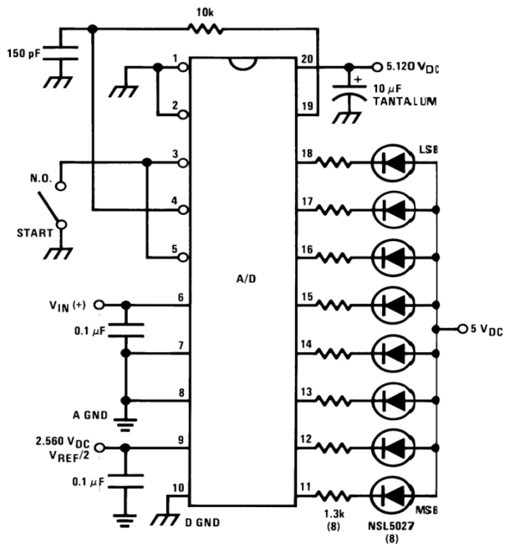Figure 1.

Source: “Lab 2: Analog to Digital Converter”

This figure shows the circuit configuration for the ADC tester with the LED bargraph display.

Figure 2.

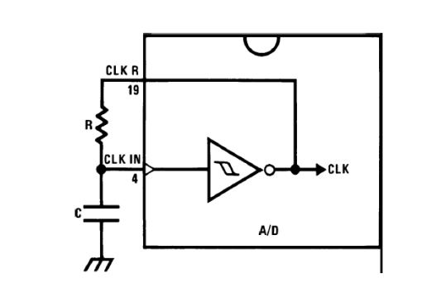

Source: “Lab 2: Analog to Digital Converter”

This figure shows the configuration of self-clock circuit of the ADC.

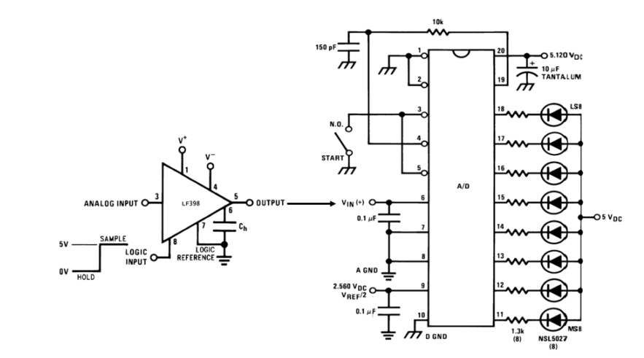Figure 3.

Source: “Lab 2: Analog to Digital Converter”

This circuit schematic shows the configuration need for sampling an AC input signal with the ADC.

Figure 4.

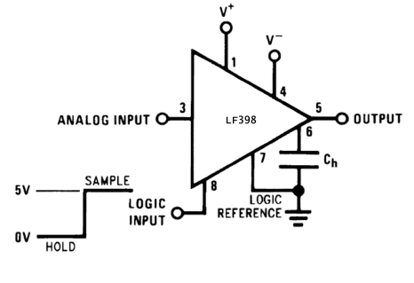

Source: “Lab 2: Analog to Digital Converter”

This schematic shows the pinout of the LF398

1. **MEASUREMENTS**
2. **DISCUSSION**
3. **CONCLUSION**
4. **QUESTIONS**
5. **REFERENCES**
6. York, B. (n.d.). Audio Amplifier Circuit. Retrieved from http://www.ece.ucsb.edu/Faculty/rodwell/Classes/ece2c/labs/Lab3_2C_2007.pdf
7. Recitation Textbook
8. “Lab 2: Analog to Digital Converter.” *Lab2 Lab Procedure*, University of Massachusetts Lowell, 2021.